**Output:**

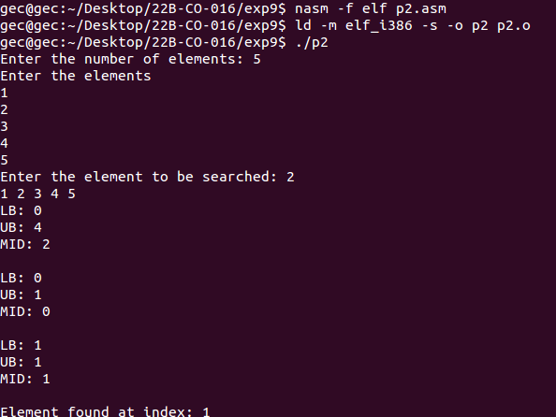

Conclusion : Program written in ASM to demonstrate use of searching algorithms was competed sucessfully